CUSTOMER BEHAVIOR ANALYSIS  
REPORT

By Qadir Bux

IMPORTING DATA

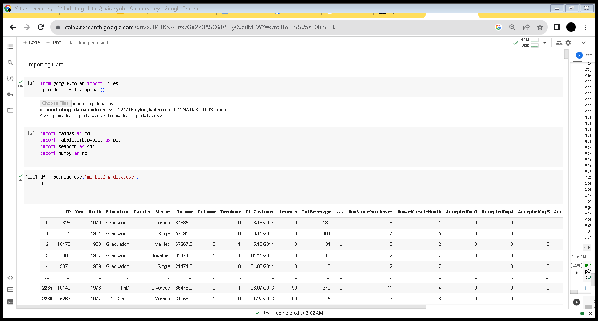

DATA DESCRIPTION

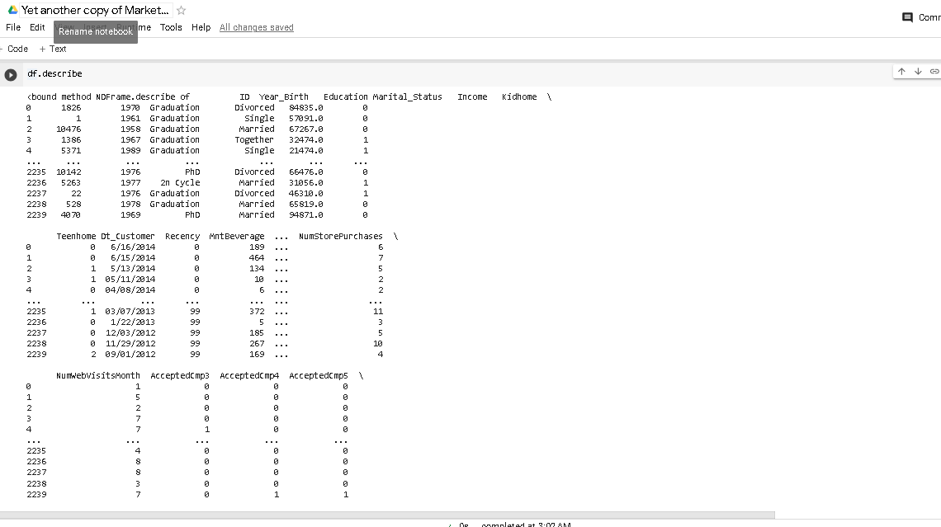



DATA CLEANING

There were 0 duplicates but there were 24 null values in income column and income column was not aligned

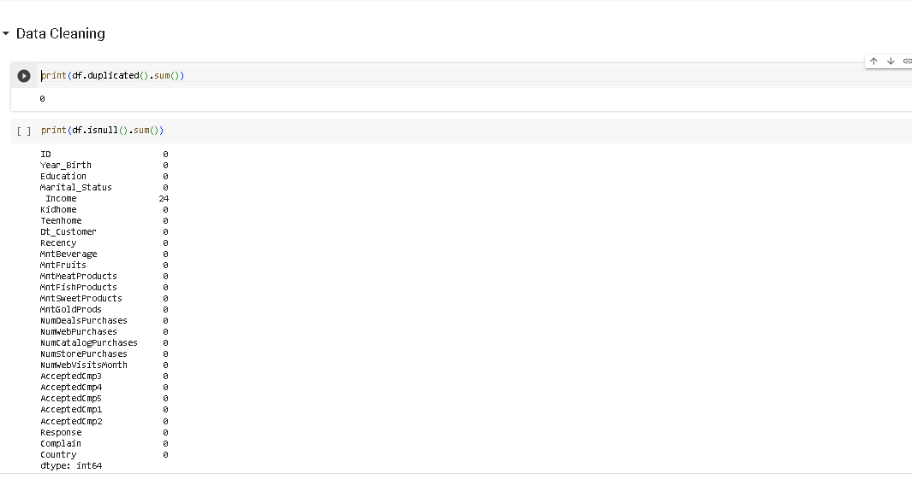

Removed the null values from income column and aligned the income column name

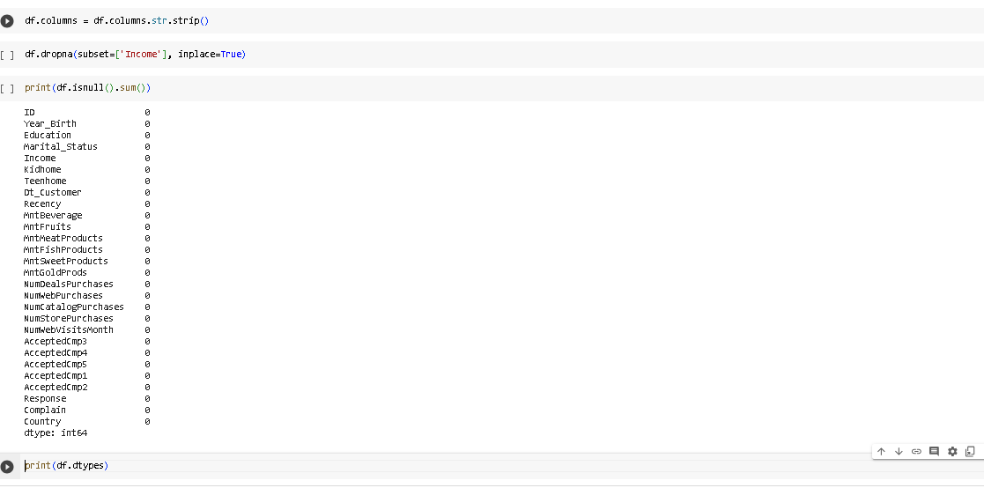

Changed the data type of Dt_customer to Date

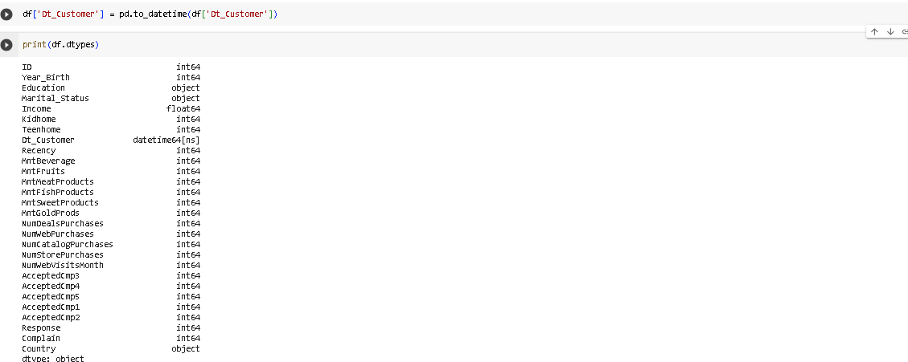

Column Names

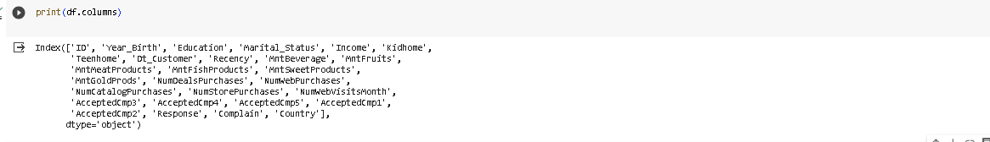

DATA INFO

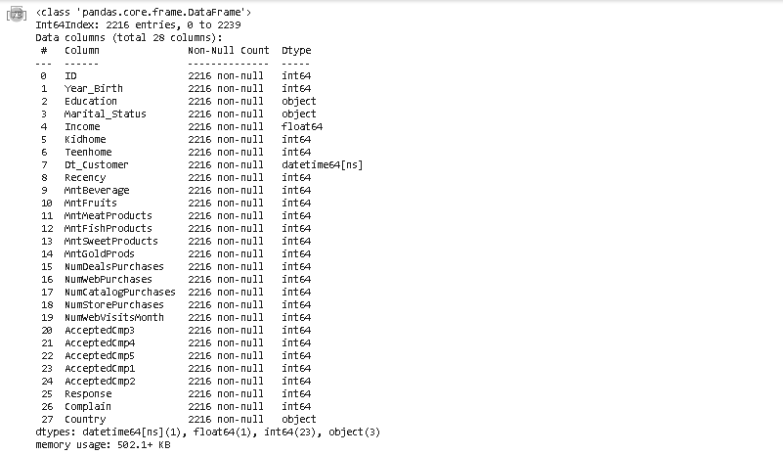

EXPLORATORY DATA ANALYSIS

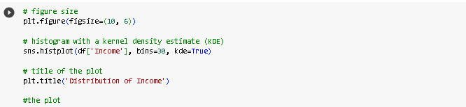

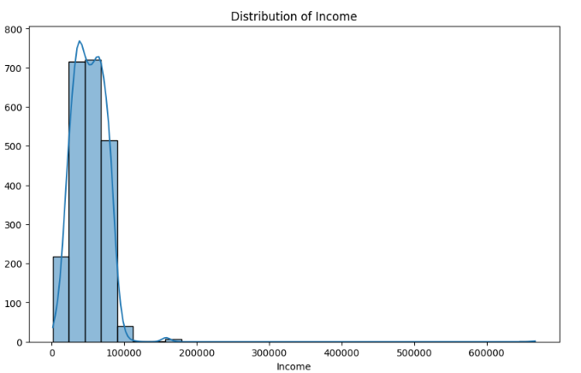

To find out customers educational background

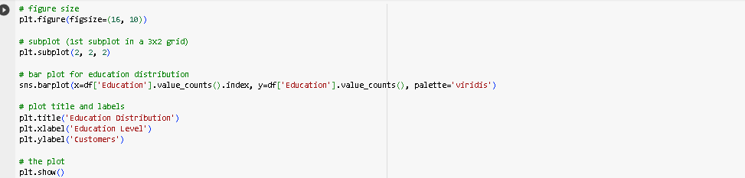

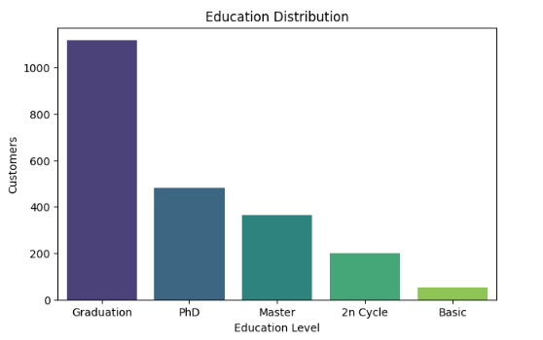

Number of Customers by Marital status

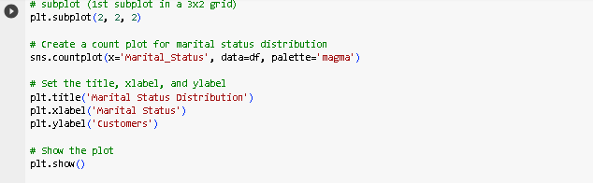

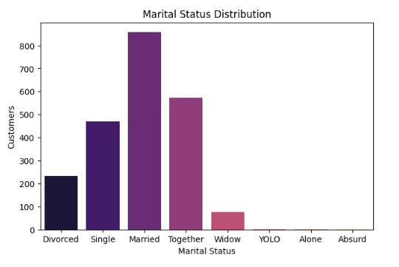

Customer acceptance rate inorder to find the effectiveness of campagns

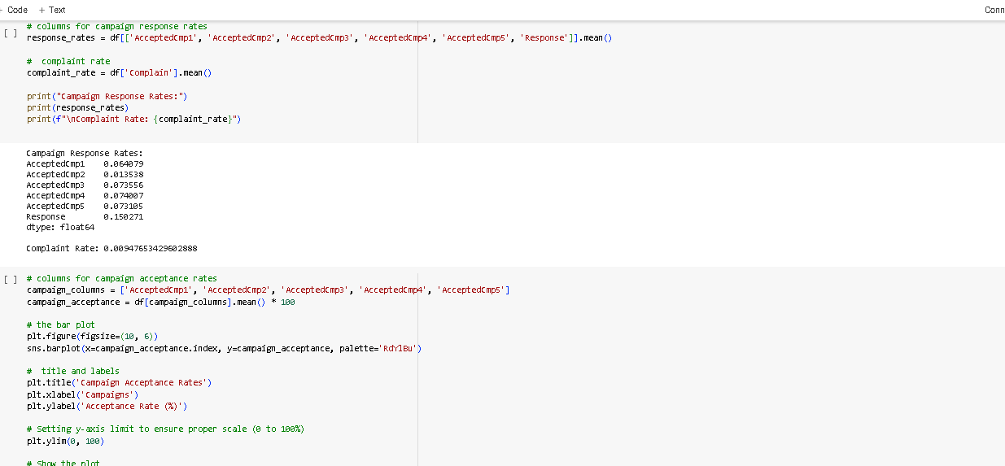

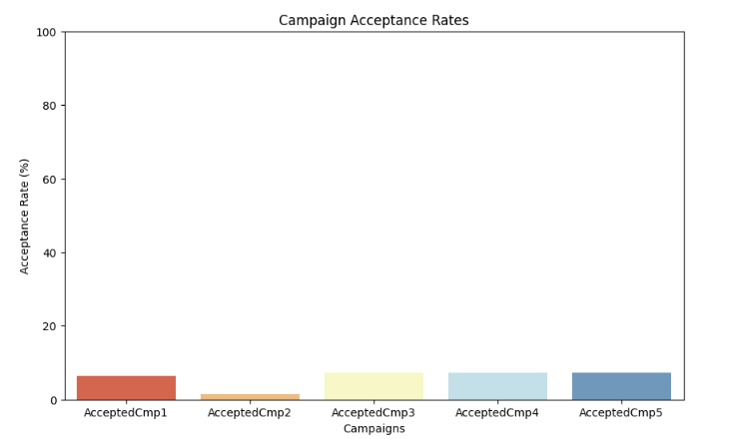

Calculated age column by birth year and created RFM as I already had recency to findout its relationship with each other and other variables

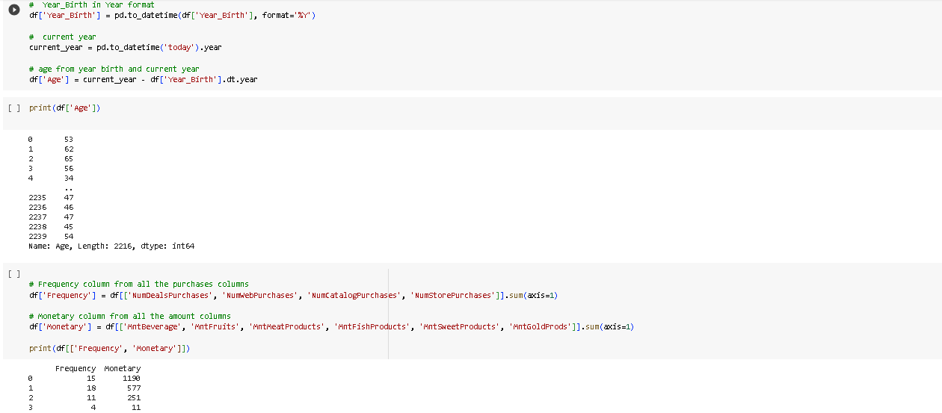

Correlation matrix of variables to find out its relationship with each other

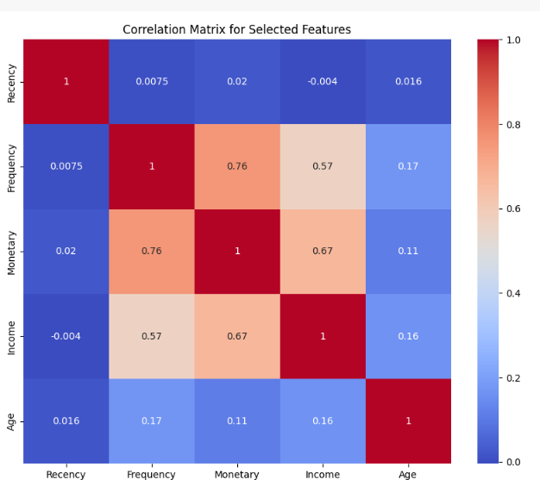

Correlation matrix of variables to find out its relationship with each other

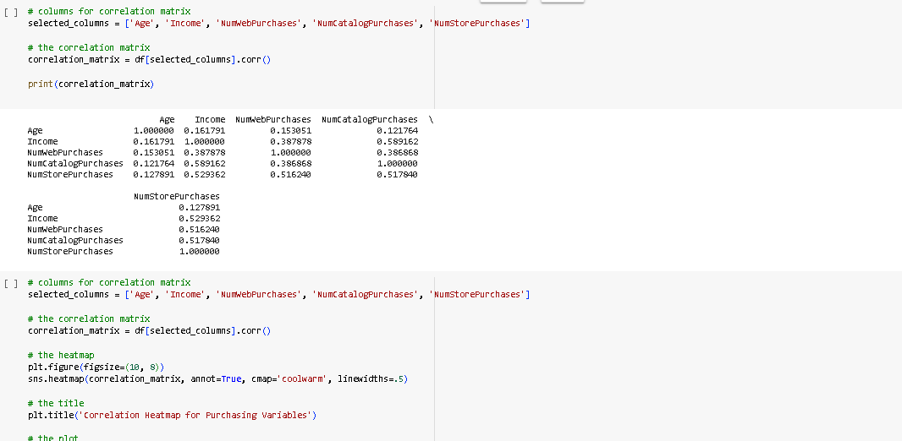

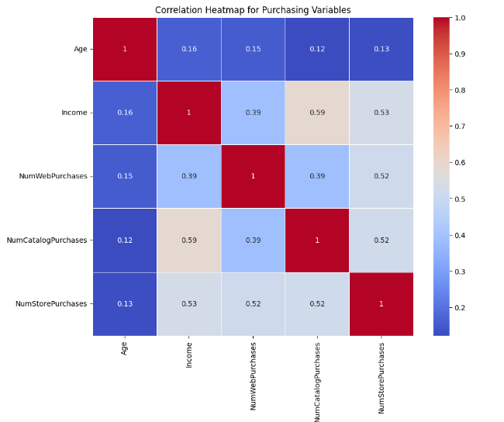

Created age groups from age column to add customers into the bins so that we get better understanding of customers demographics

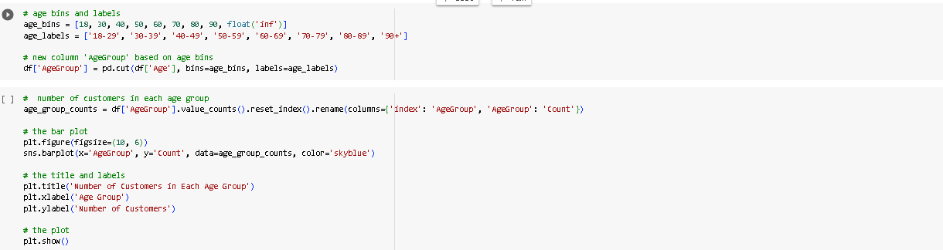

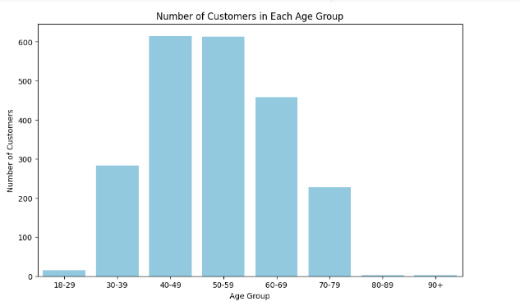

Created total income spending column so that we can understand the spending behaviour of the customers and also created income group so that we can categorize customers based on their income

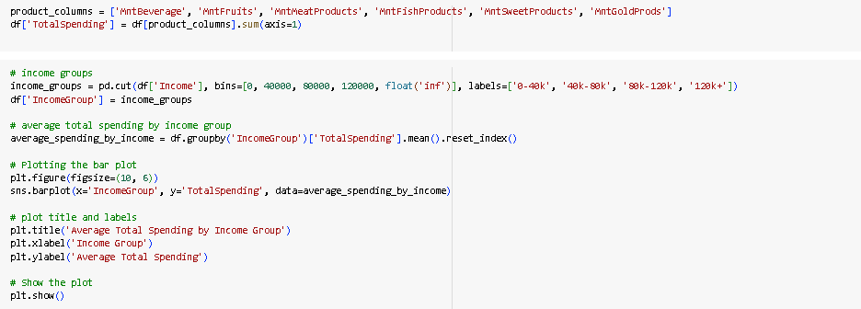

Calculated total average total spending by income group

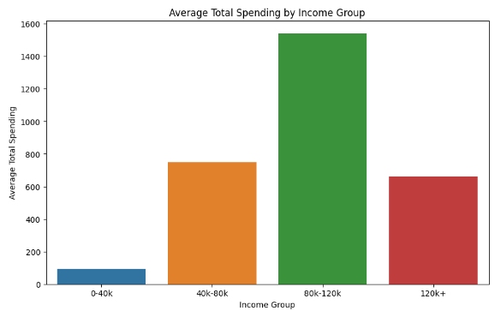

Created average total spending by age group in order to findout the highest average spenders by age group.

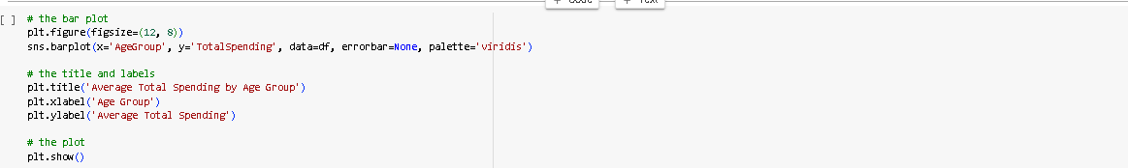

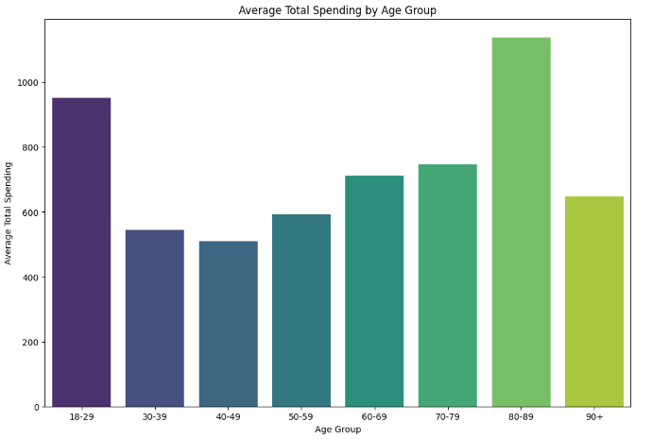

Created total purchases column to find the total purchases of customers

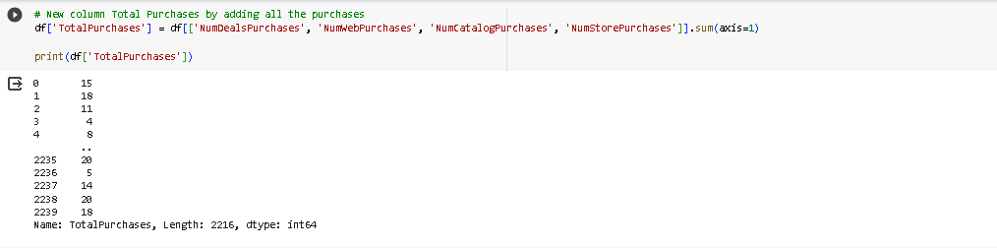

Created average number of purchases by age group

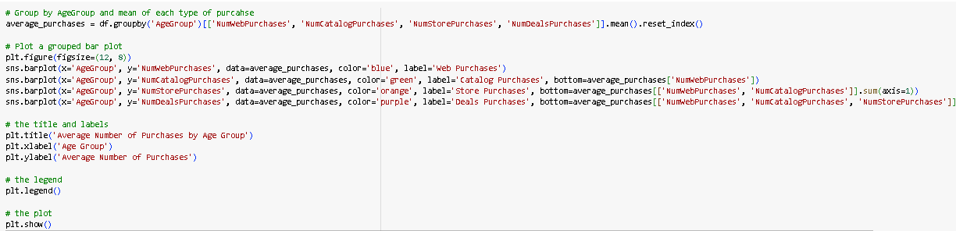

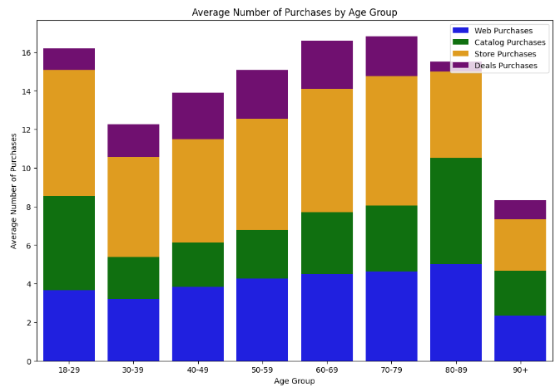

Created number of customers by country to find out the customers geophraics

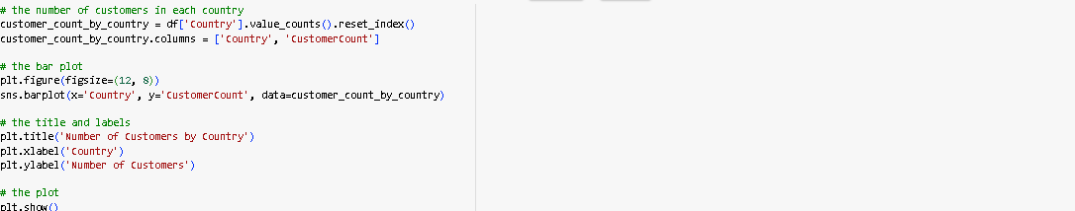

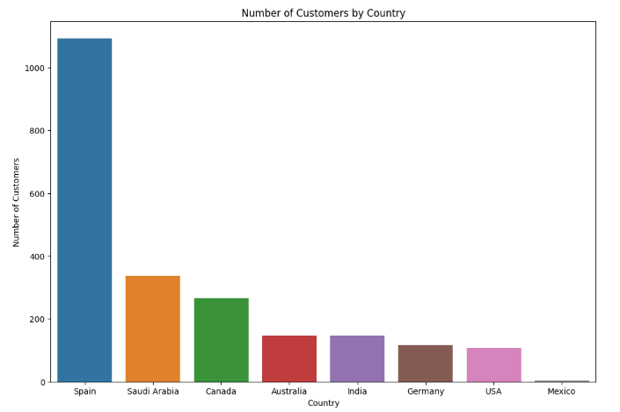

Created average income by country

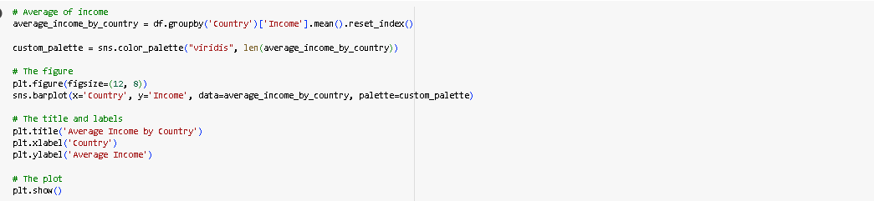

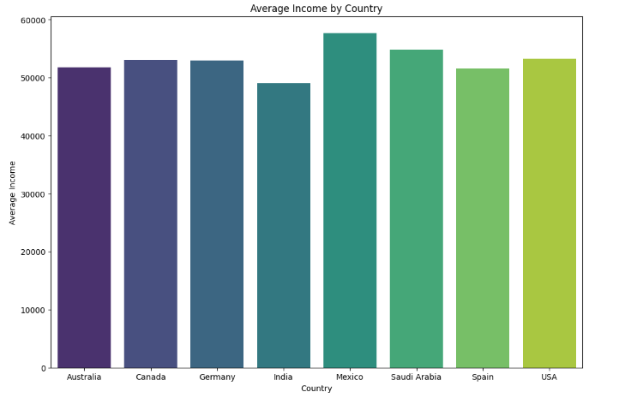

Created total purchases by country

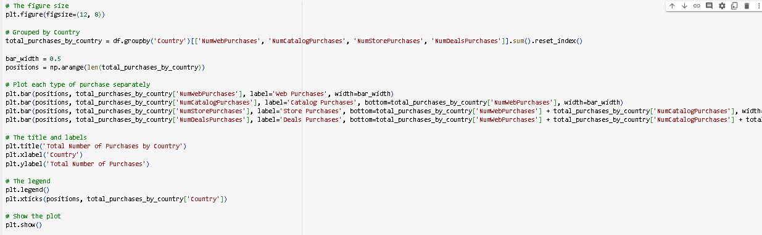

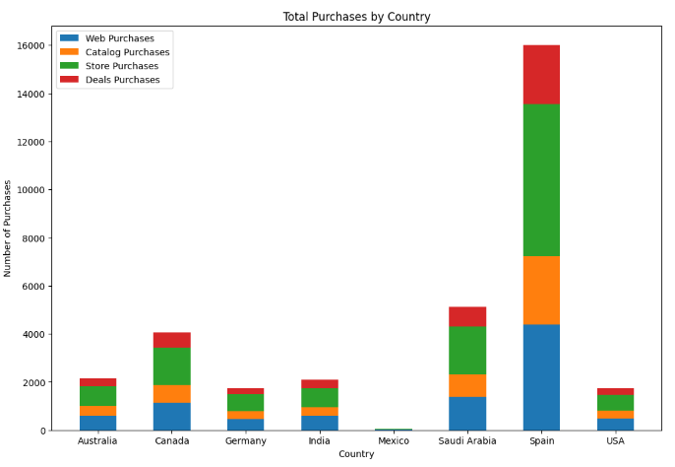

Created average purchase by country

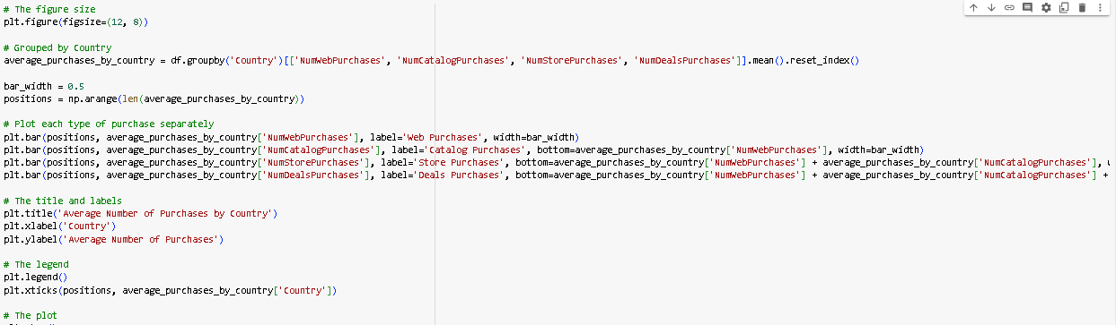

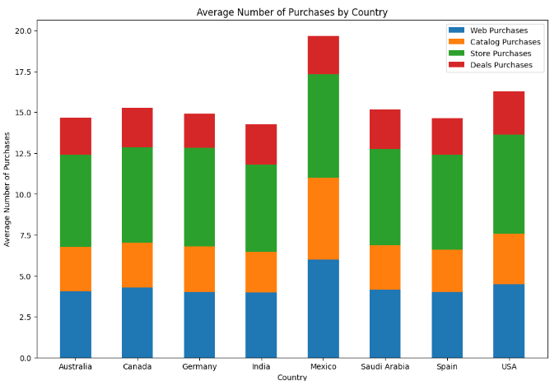

Created total spending by country

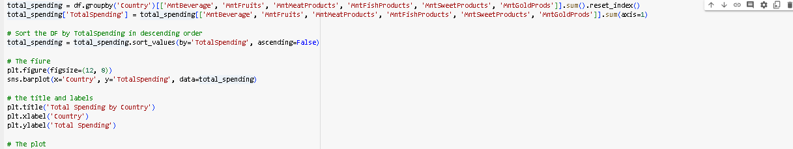

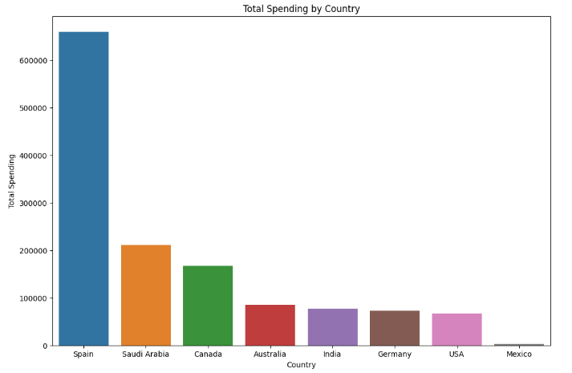

Created average spending by country

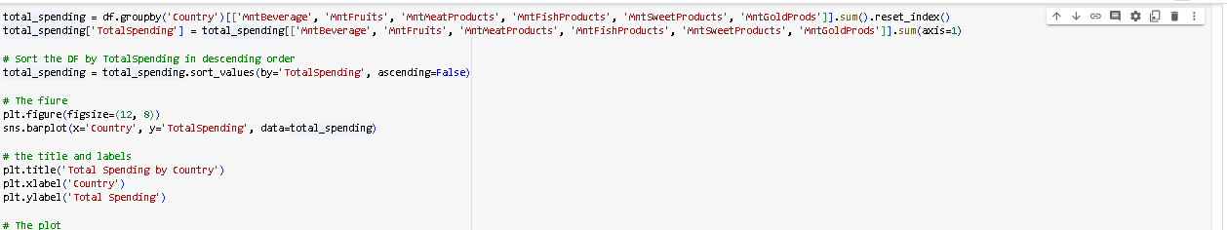

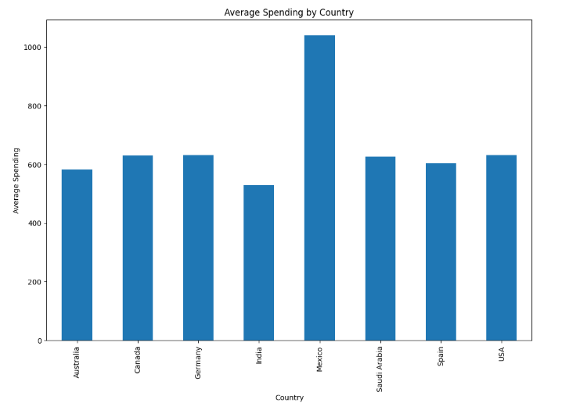

DASHBOARD

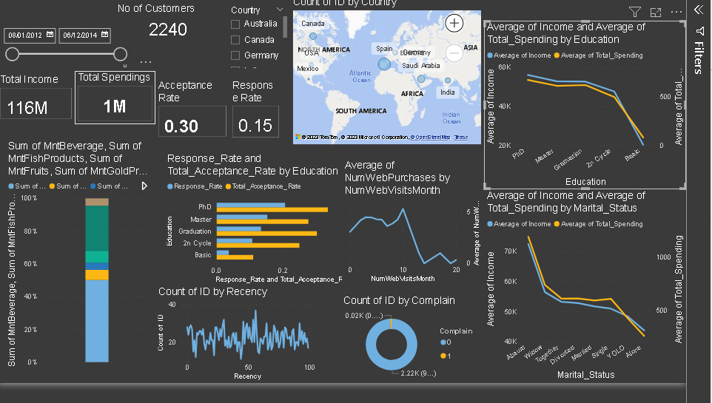

AVERAGE INCOME AND AVERAGE TOTAL SPENDING BY EDUCATION

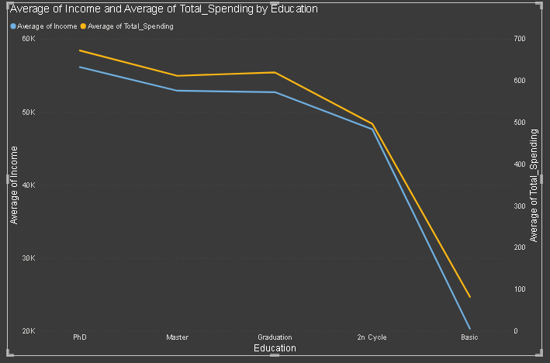

AVERAGE INCOME AND AVERAGE TOTAL SPENDING BY MARITAL STATUS

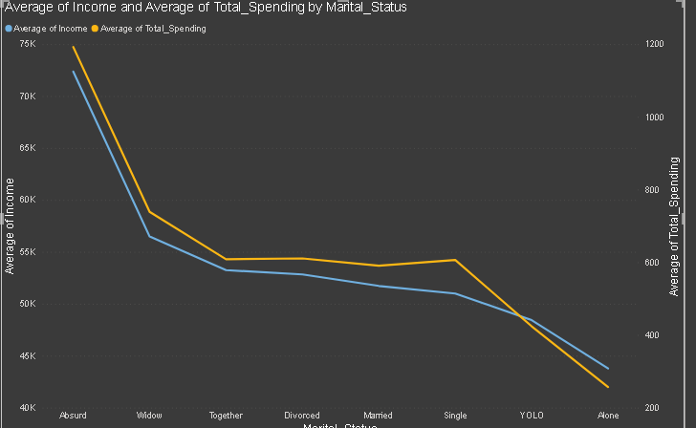

ACCEPTANCE RATE AND RESPONSE RATE BY EDUCATION

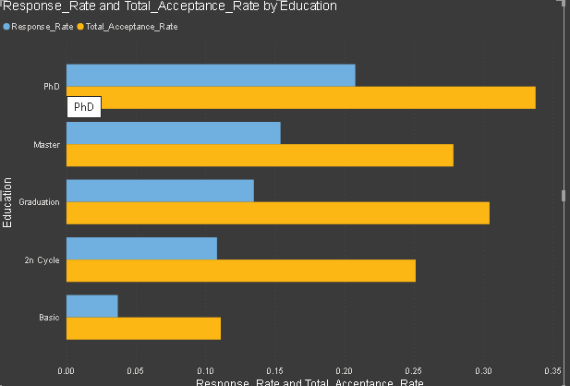

ACCEPTANCE RATE AND RESPONSE RATE BY COUNTRY

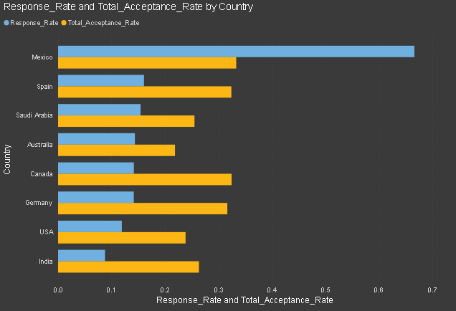

COUNT OF RECENCY BY AGE

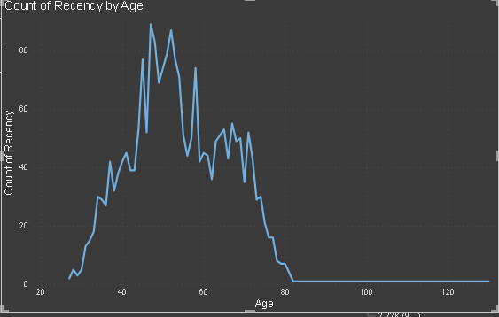

SUM OF EACH PRODUCTS BY MARITAL STATUS

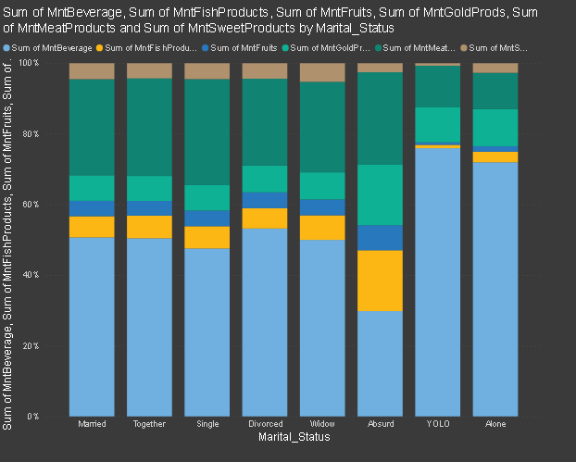

INSIGHTS

* Most of the customers income ranges between 20k to 100k
* Most of the Customers educational background is Graduation followed by PHD, Masters.
* Most of the customers marital status is Married followed by Together, Divorced and single
* All the recent market campaign were accepted below 10%
* Monetary and Frequency have strong relationship
* Income has good positive relation ship with Monetary and Frequency.
* Income have strong relationship with all the purchases types
* All the purchases have strong relationship with eachother
* Most of the customers were aged 40 to 59 followed by 60 to 69 , 70 to 79 and 18-29
* The aged-group who had lower customer had high spending average and purchases average
* Spain had the most number of customers while mexico had the lowest
* Mexico had the average income while the rest of the countries had similar and india had the lowest
* Spain had the highest total purchases followed by Saudi arabia, Cananda, Australia , USA, India and Mexico
* Store Purchases were the highest followed by Web Purchases, Catalog Purchases and Deals Purchases
* Mexico had the highest average purchases
* PHD holders had the highest average income and average spending followed by Masters,
* Graduation, 2nd Cycle and Basic
* PHD holders had the highest acceptance rate and response rate while australia had the lowest total
* acceptance rate and india had the lowest total response rate
* Overall the beverage had generated the highest amount but YOLO and Alone had way much higher beverage while Meat products and gold products were second and third most sold followed by fishproducts while fish products had the most sales in Absurd type of Marital status.
* Only 21 customers had complained
* The average purchases increased as the number of visited increased till some point

RECOMMENDATIONS

* We need to target customers income ranged from 20k to 100k , graduated and married as the are the majority of our customers.
* We need improve our marketing campaigns are effective by setting our target audience
* Also we need to cater customers of high income as they tend to purchase and spend more
* We need to understand customers channel preferences and attract them to use one of them.
* Retain customers from aged 40 to 59 and attract other age group with fewer customers but have higher average spending
* and purchases
* Attract more customers from countries which have lower customer as they have high average spending and purchases
* Make all the channels effective as they tend to bring more purchases
* Target customers of high level of education as they have spend more
* Personalized marketing based on the marital status will be beneficial